Lab 05 – IAM

- Create a user with console access
- Attach policy for full admin access

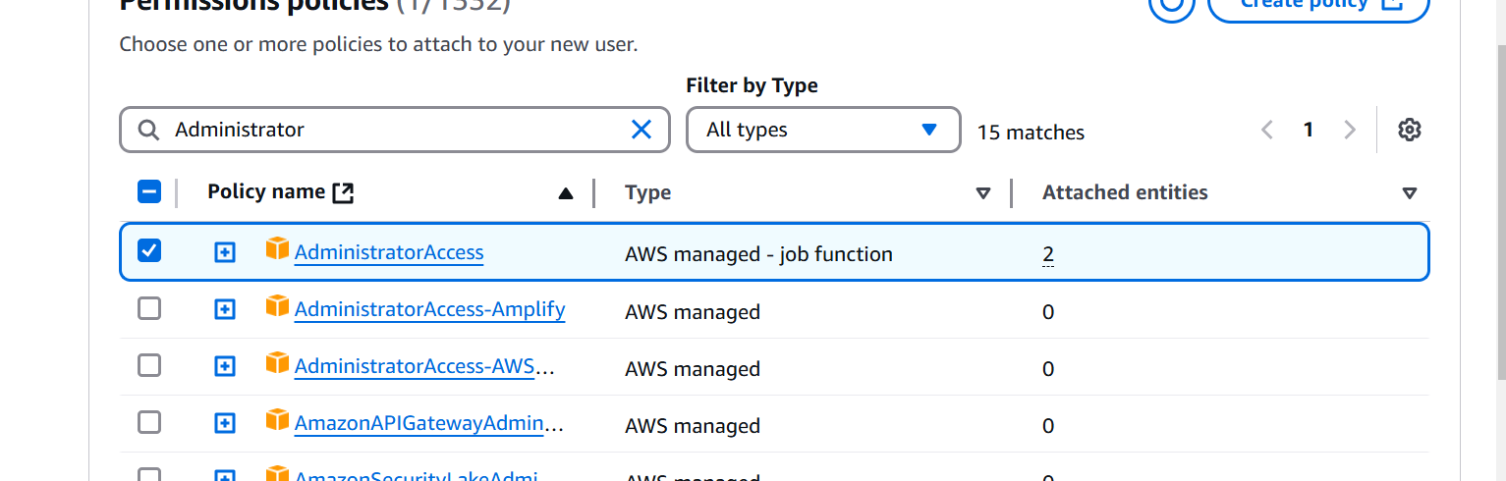

Go to userSecurity Credentials
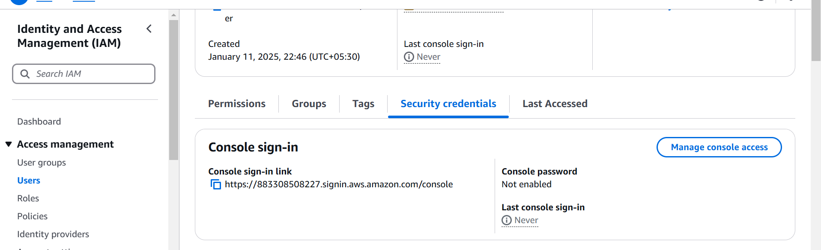
Click on Access keys
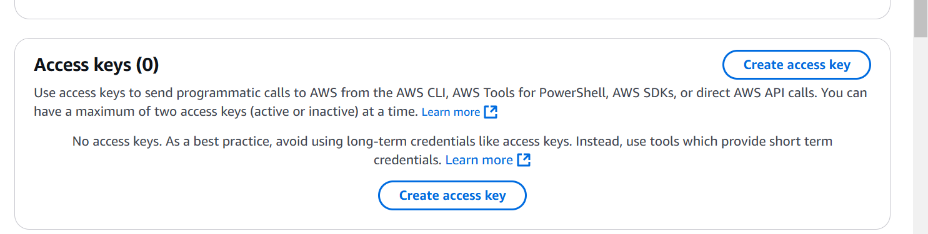

Select CLI options
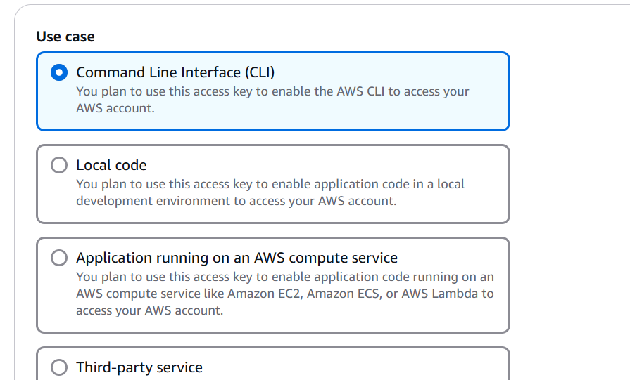

Create access key

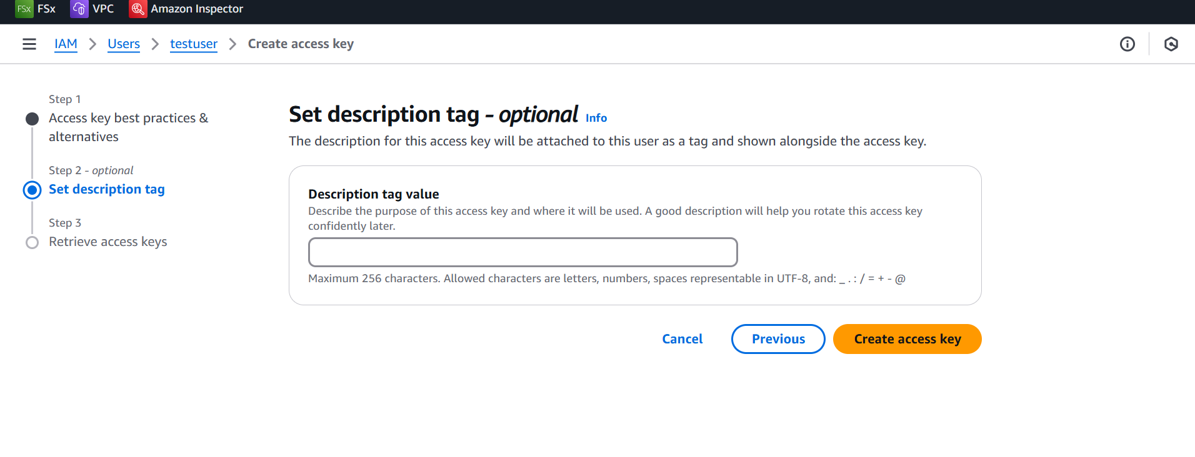

Download the csv

Install aws cli
https://docs.aws.amazon.com/cli/latest/userguide/getting-started-install.html
Download the msi
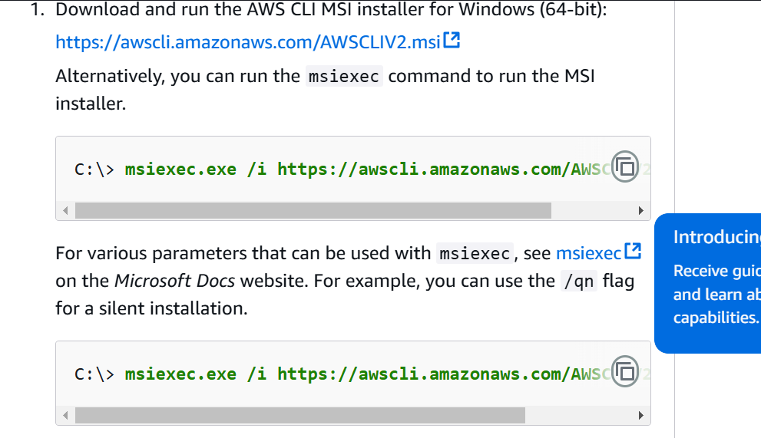

Install the msidouble click on msifinish the installation
Open powershell and type aws
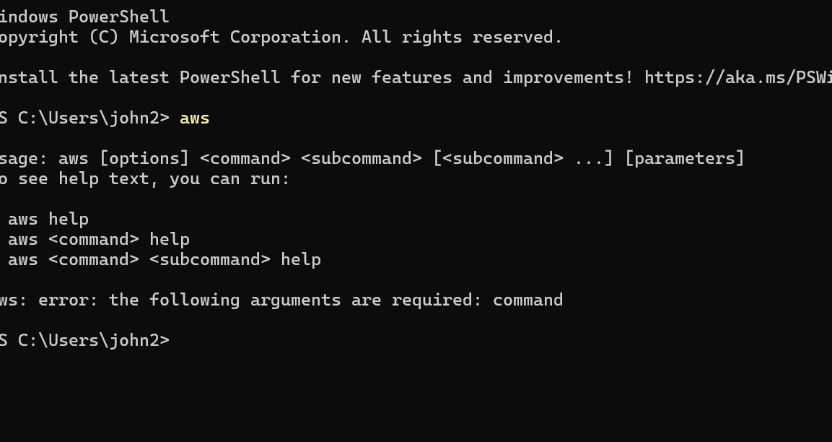

Run the command
aws configure

PS C:\Users\john2> aws configure
AWS Access Key ID [None]: (provide your access key)
AWS Secret Access Key [None]: (Provide your secret)
Default region name [None]: ap-south-1
Default output format [None]: text

Run the command to test

aws s3 ls

